

**Introduction to Databases**

**DATABASE SYSTEM PROJECT – FINAL**

**ELİF NUR ASLIHAN CELEPOĞLU**

**COMPUTER ENGINEERING**

**1)Brief Description of the System**

The main goal of our project is to design an application that helps people watch movies.

and it helps to offer the convenience of viewing the version in each language throughout the day.

When we are bored or for fun, we watch movies with the pleasure we want on the movie platform that everyone makes. This is why we can explain that the data I have made is very important and important. For example, among the companies that earn the most in Turkey, 10% of them are companies that make film platforms. This is a very large ratio and share.

In this project, we can also use a platform where we can provide detailed information about the movie. In other words, it will be a platform that informs even the teams how and where the movie we watch. made with a different point of view.

The goals of our system are:

1. That customers can seamlessly monitor anywhere

2. To keep customers data more securely

3. To provide up-to-date information about the movie we watched

4. Watch the movie you want in the language you want

**1.1 Scope Definition**The movie monitoring system consists of a mobile application and thanks to the system, customers can ,you can watch movies wherever you want and get information.

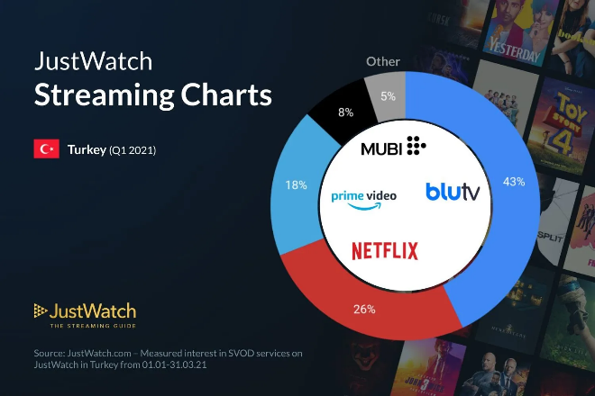

**MOVIE DATABASE :: ERD (entity relationship diagram)::**

* 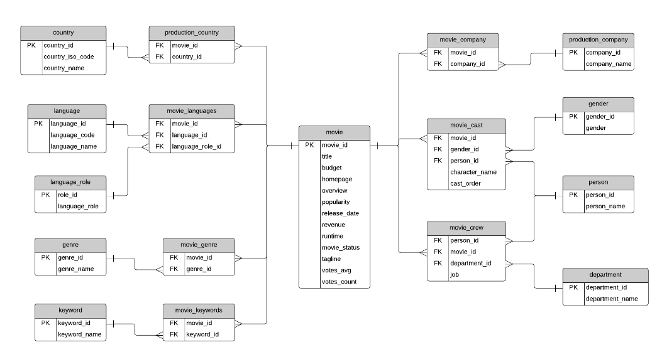Use draw io online.
* In the table names:
* Country
* Production_country
* Language
* Movie_language
* Language_role
* Genre
* Movie_genre
* Keyword
* Movie_keywords
* Movie
* Movie_crew
* Person
* Movie_cast
* Movie_company
* Production_company
* Gender
* Person
* department

**1.3 Entities**

* **Database related brief information and content**.

This database stores information about movies, the cast and crew involved, where the movie was produced and by which company, and other information about movies such as the languages, genres, and keywords.

* **Table Explanations:**

-The **movie** table contains information about each movie.

-There are text descriptions such as title and overview. Some fields are more obvious than others: revenue (the amount of money the movie made), budget (the amount spent on creating the movie).

-Other fields are calculated based on data used to create the data source: popularity, votes_avg, and votes_count. The status indicates if the movie is Released, Rumoured, or in Post-Production.

-The **country** list contains a list of different countries, and the **movie_country** table contains a record of which countries a movie was filmed in (because some movies are filmed in multiple countries).

-This is a standard many-to-many table, and you’ll find these in a lot of databases.

-The same concept applies to the **production_company** table.

-There is a list of production companies and a many-to-many relationship with movies which is captured in the **movie_company** table.

-The **languages** table has a list of languages, and the movie_languages captures a list of languages in a movie. The difference with this structure is the addition of a **language_role** table. This language_role table contains two records: Original and Spoken. This is captured in the movie_languages table along with a role.

-**Genres** define which category a movie fits into, such as Comedy or Horror. A movie can have multiple genres, which is why the **movie_genres** table exists.

-The same concept applies to **keywords**, but there are a lot more keywords than genres.

- This database contains a table called **person**, which has each person’s name.

-The **movie_cast** table contains records of each person in a movie as a cast member.

-It has their character name, along with the cast_order, which I believe indicates that lower numbers appear higher on the cast list.

-The **movie_cast** table also links to the gender table, to indicate the gender of each character.

-The **movie_crew** table follows a similar concept and stores all crew members for all movies. Each crew member has a job, which is part of a **department**.

**1.4 Components of the Entity Relationship Model**

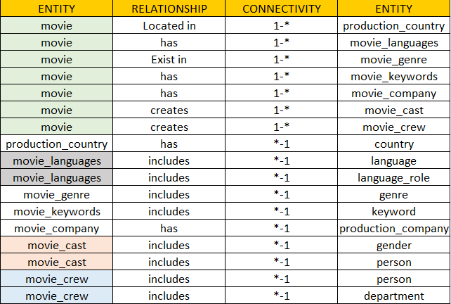

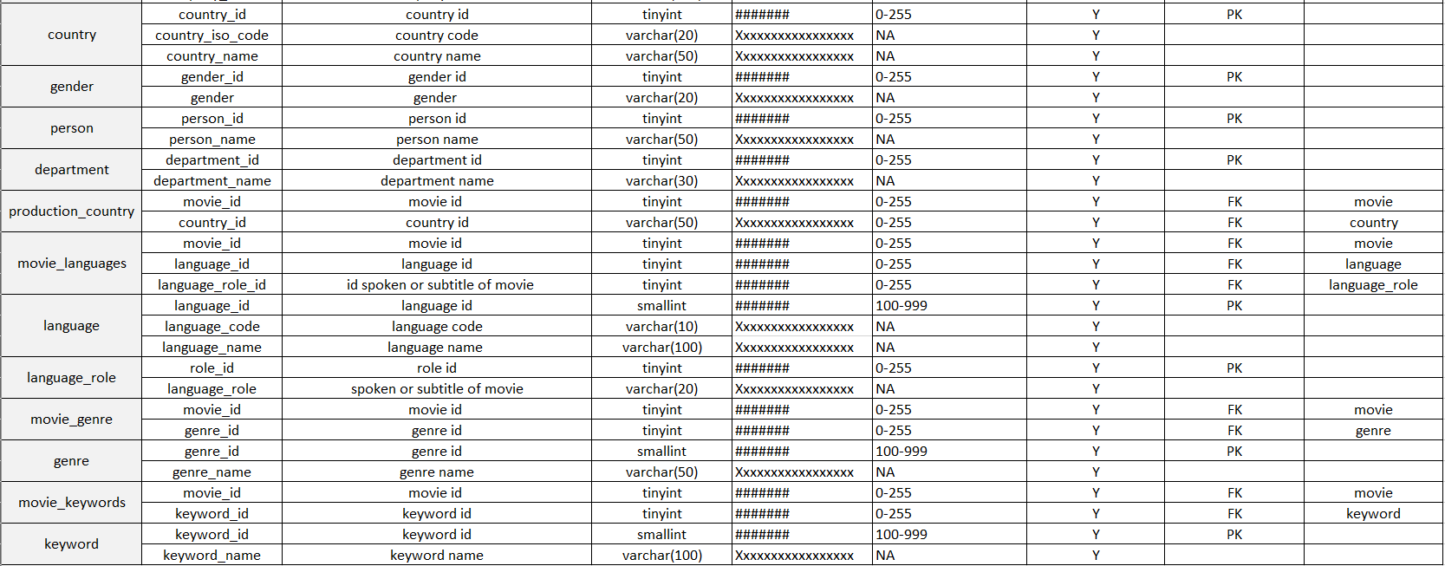**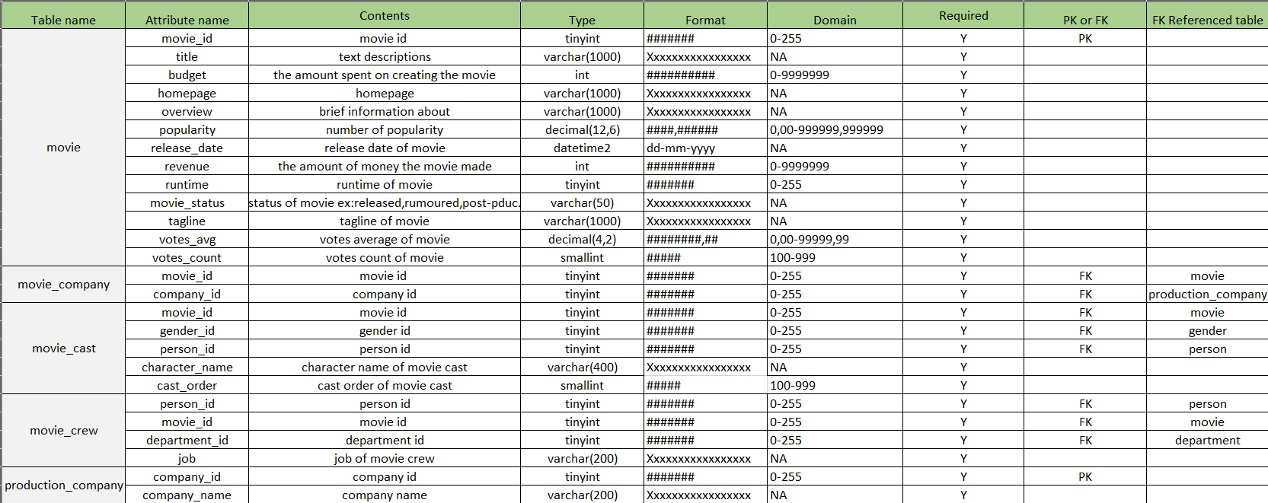1.5 Data Dictionary**

* FK = Foreign Key
* PK=Primary Key
* VARCHAR = Variable character length data, 1 to 4000.
* INT = Integer values only.
* SMALLINT = Small integer values only.
* TINYINT=The smallest integer data type
* DATATIME2= Date and time
* DECIMAL=To specify numbers with two decimal places
  1. **OUTPUTS SQL QUERIES**

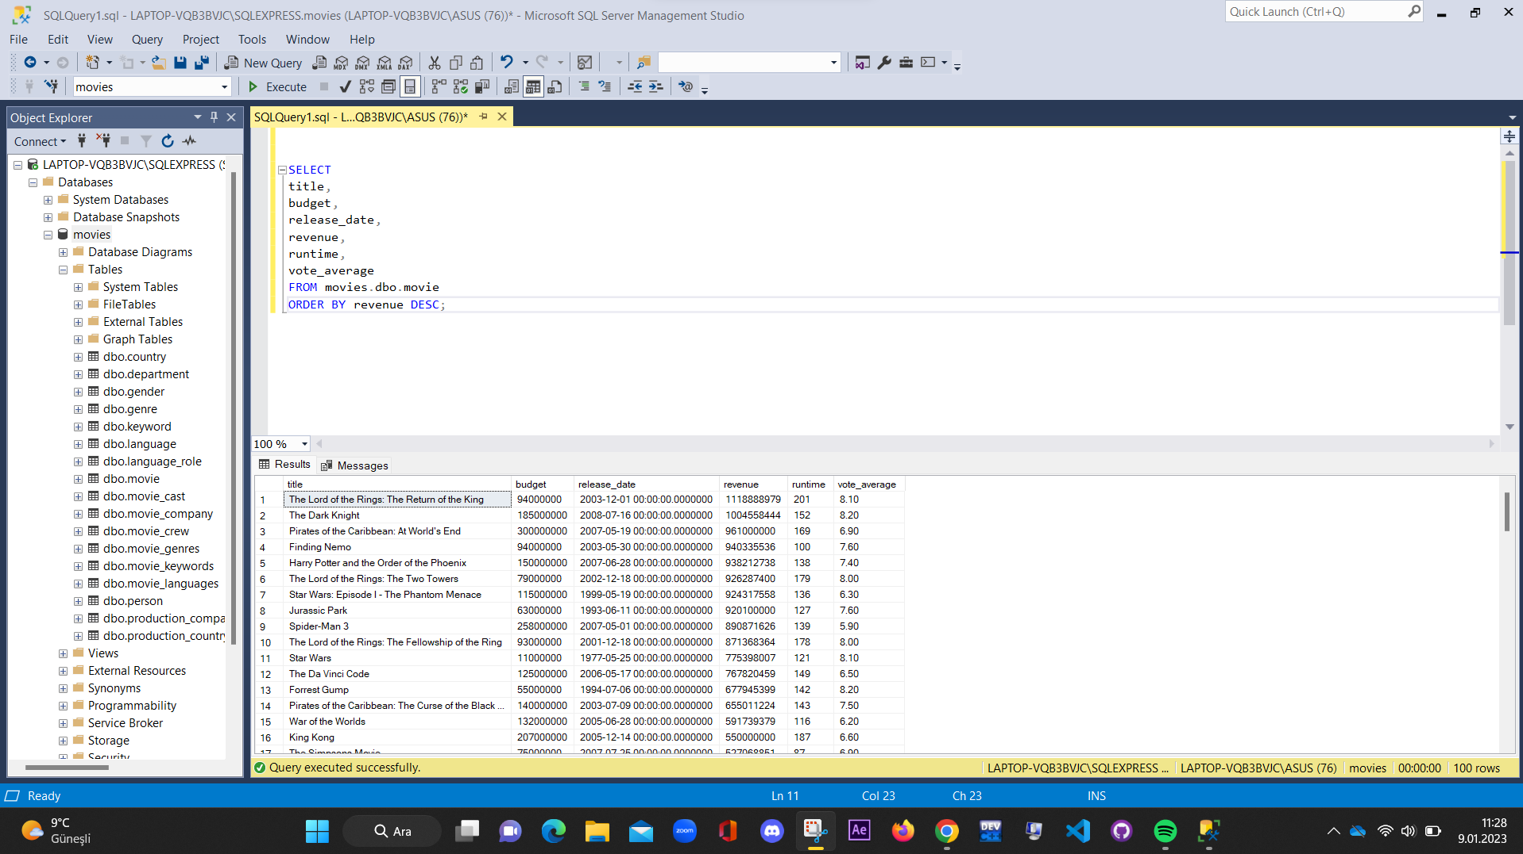**1)This query shows the movie title, budget, and other attributes of the movie, sorted by the movies with the highest revenue.**

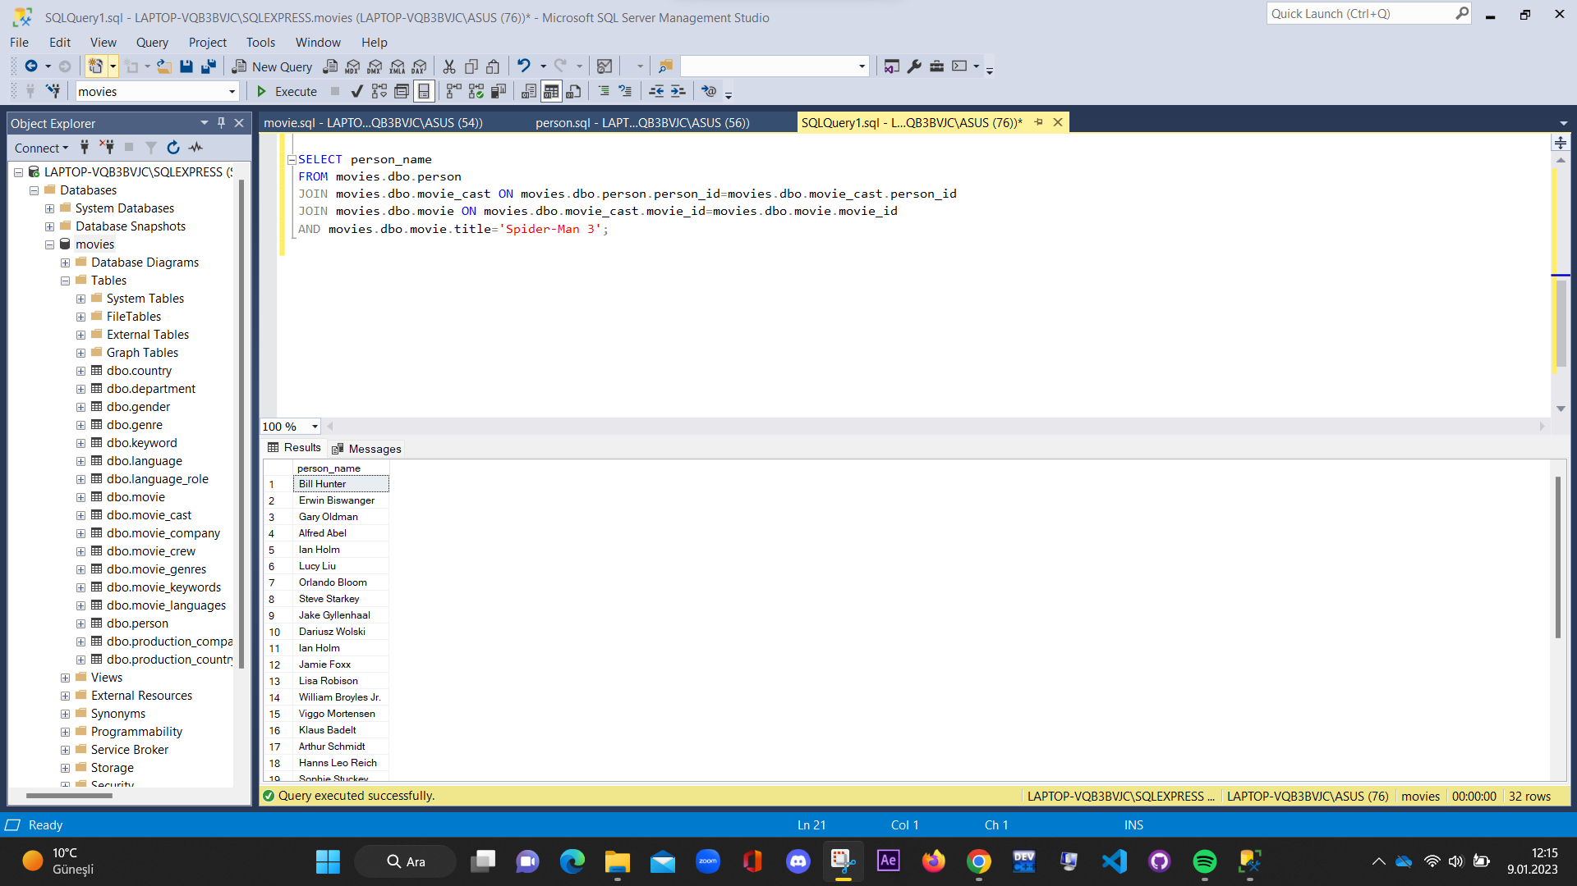**2) This query shows to find who ıs at the title of that movie.**

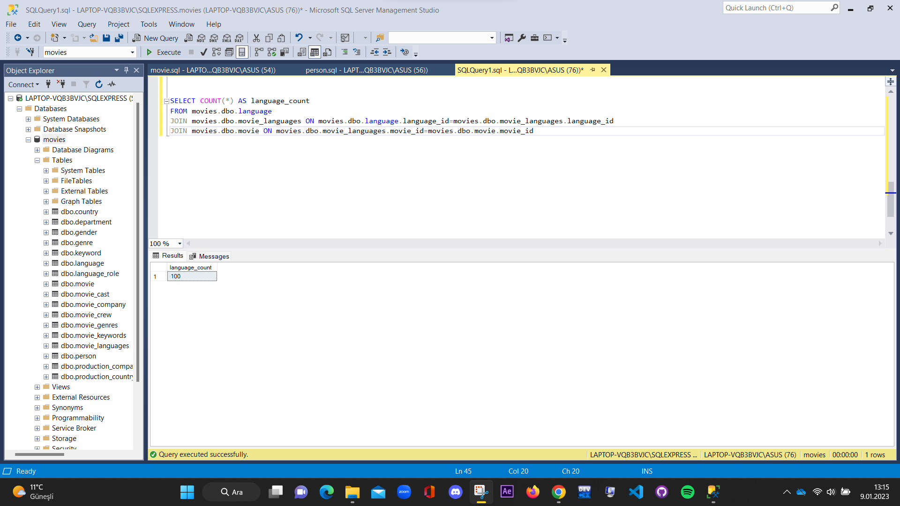**3) This query shows how many languages ​​are used in the total movies as a total number.**

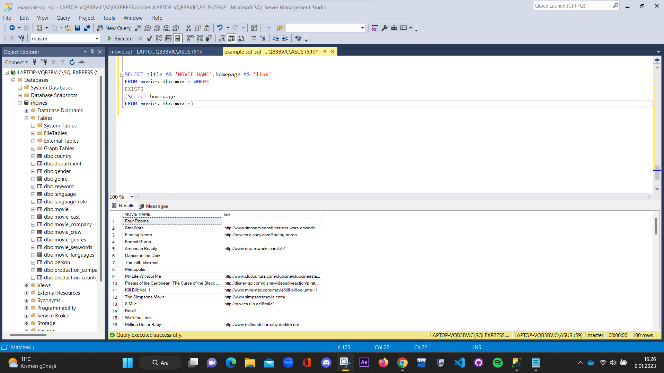**4) This query shows which movie the link has.**

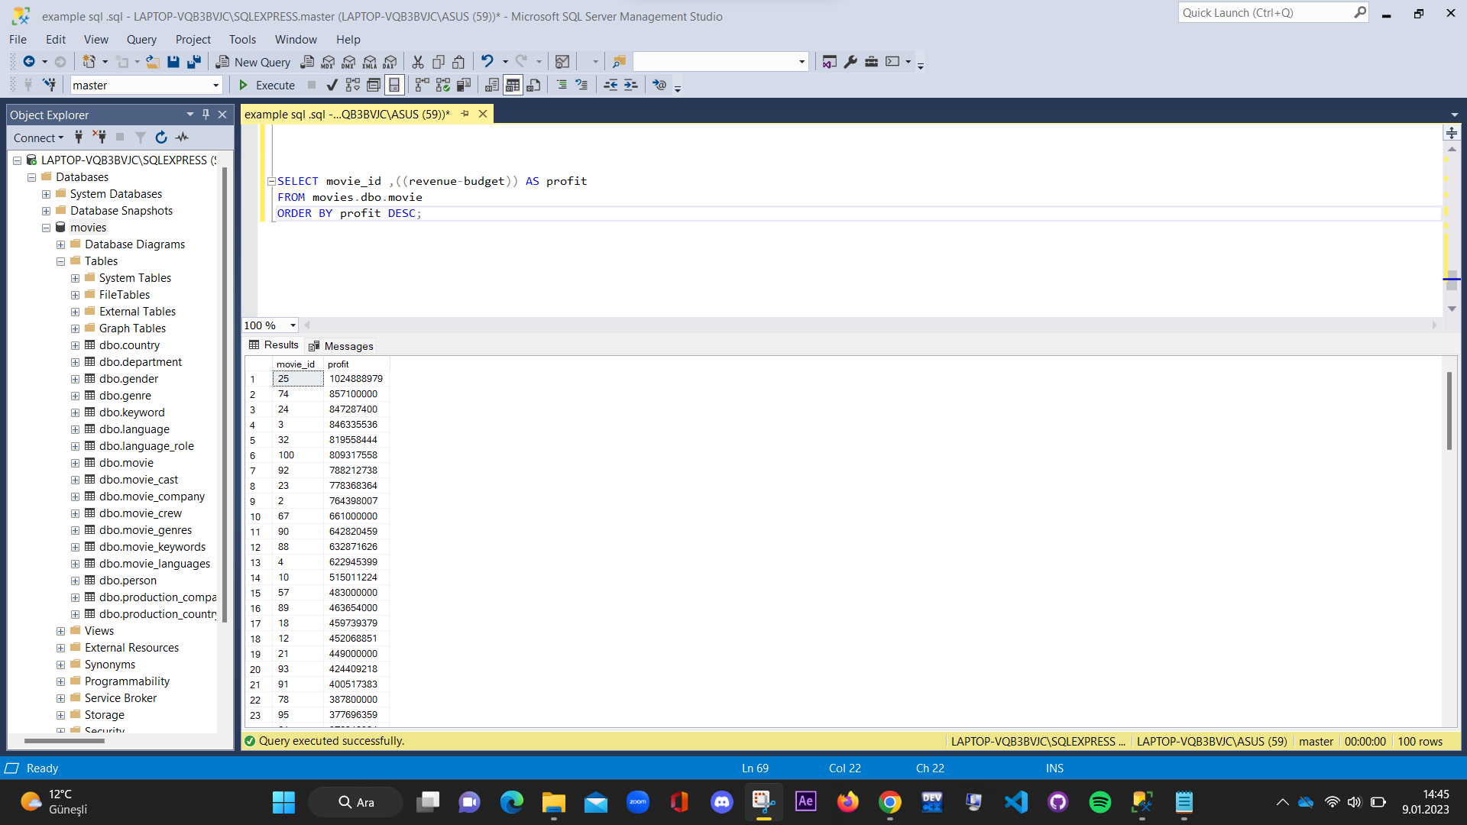**5) This query shows calculating and ranking the profit amounts of films.**

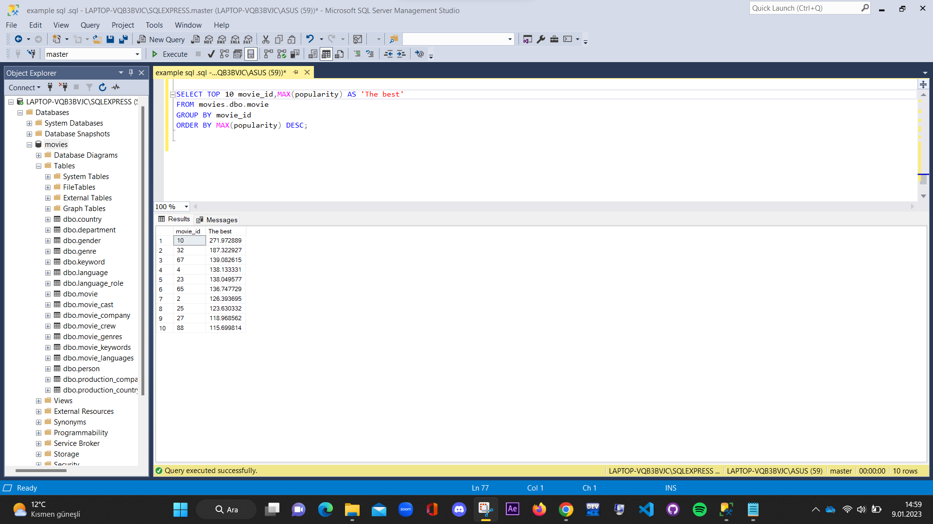**6) This query shows the ten best movies.**